**Booking a room documentation**:

The booking a room page has shown below:

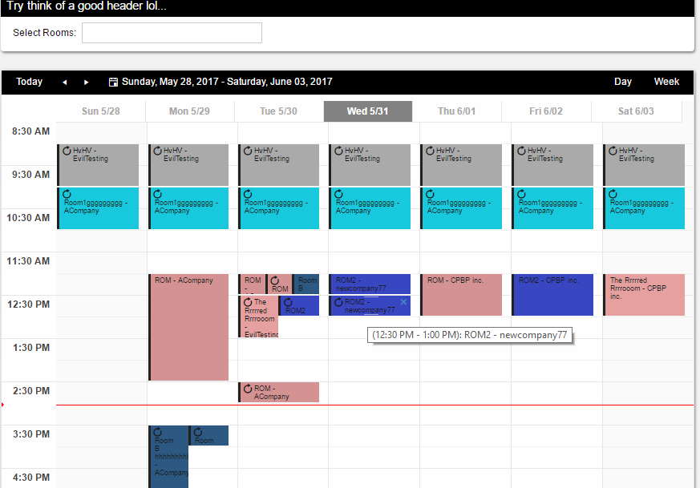

**Select rooms:** It is multi select drop down list and It contains the room lists. User can filter the booked rooms by selecting the rooms. The selected rooms appear on the booking calendar page.

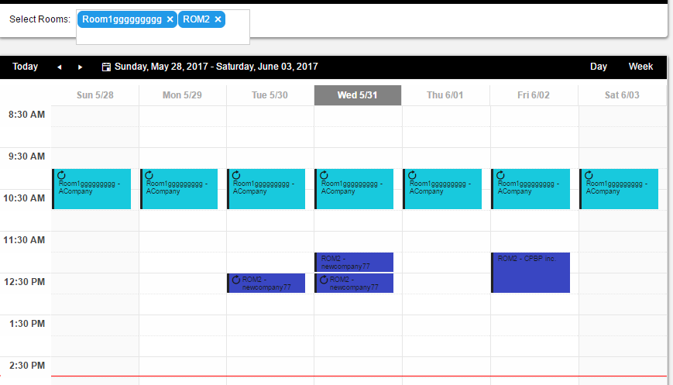

After clicking on a booking page user see the pop for booking a room.

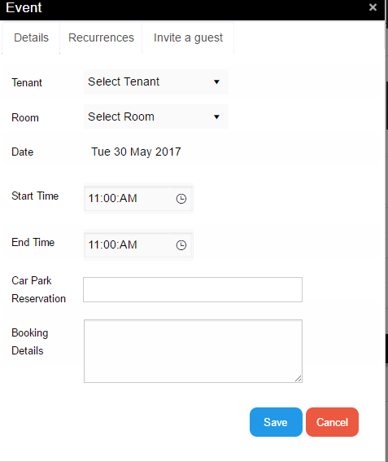

In the above user can see a TabStrip: It has three items. They are Details, Recurrence, Invite a guest

**Details:** In this section user can see all the booking details.

1.Tenant: It is for selecting the tenants(Companies). User must select a tenant name to book a room or else the system throws an error.

2.Room: User can select a room from the lists of the dropdown. It is a compulsory field therefore, User must select a room otherwise system throws an error.

3.Date: This shows the current date for the users.

4.Start Time and End Time: These two are the dropdowns they display time as user clicks on them. The starting time should be greater than the end time or else system throws an error.

5.Car Park Reservation: It is a multi-selection dropdown user can select car parking as he/she wants to invite the guests for the meeting. If User select already reserved cap parking space then system throws an error.

6.Booking Details: User can write a detail of the booking in the text area.

After filling out all the above fields user can click on a **Save** button to book a room for the meeting.

**Recurrences:** After clicking on Recurrences tab then user can see the below dropdown. In the dropdown user can see the three dropdown list items.

**Never dropdown** item is a default one so user should not be able to make a booking recursive.

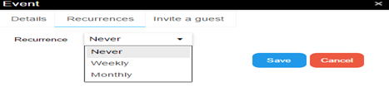

After clicking on **Weekly** dropdown list item user can see the weekly booking recurrence.

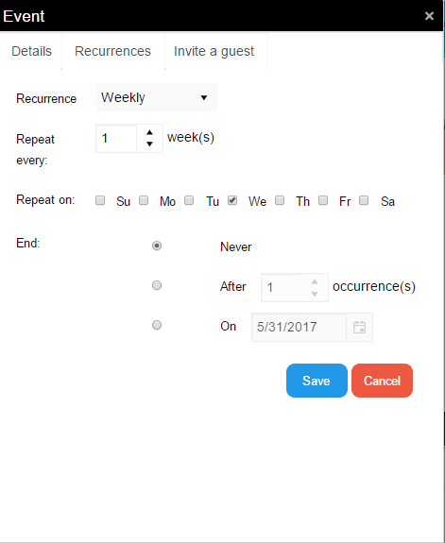

**Repeat every:** User can repeat the booking in terms of week by increasing the numeric textbox.

**Repeated on:** User can choose on which day he/she wants to repeat the booking.

**End:** At this point, User can see the three checkboxes those three are for different purposes.

If a user click on **Never check box** then the bookings will be recursive consecutively based on the above repeated fields.

If a user click on **After check box** then he/she can end the booking occurrences by using numeric text box.

If a user chooses **On check box** then he/she can end the booking occurrences on a required date.

Click on a **Save** button to save the booking details with the recurrences as user required.

After clicking on **Monthly** dropdown list item user can see the layout of monthly recurrence.

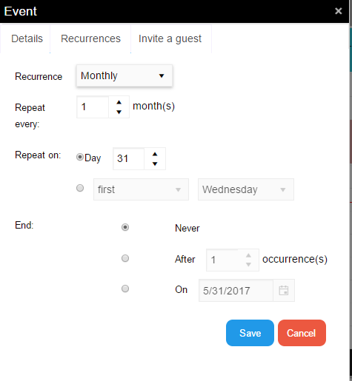

Repeat every: User can repeat a room booking on monthly bases by using numeric text box.

Repeat on: By clicking the Day check box user can make the bookings recurrence on what day he/she wants to.

The below **check box** which is next to **first** dropdown, by clicking it user can able to repeat the booking ocurrence at a particular day of the consecutive weeks.

**End:** At this point, User can see the three checkboxes those three are for different purposes.

If a user click on **Never check box** then the bookings will be recursive.

If a user click on **After check box** then he/she can end the booking occurrences by using numeric text box.

If a user chooses **On check box** then he/she can end the booking occurrences on a required date.

Click on a **Save** button to save the booking details with the recurrences as user required.

**Invite a guest:** By clicking on Invite a guest tab user can invite a guest to the meeting.

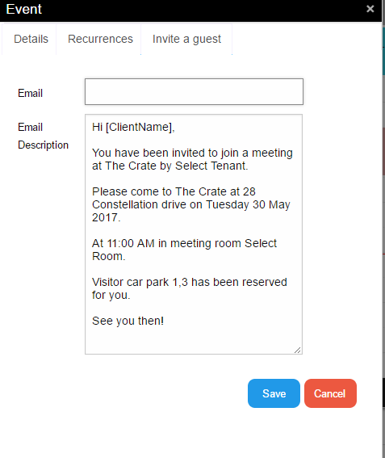

In this section, there are two field to fill out to invite a guest.

**Email**: It is a text box user can enter guest email to invite.

**Email Description:** In the this, user can see all the booking information and can enter client name extra information. This information goes to the guest after clicking a **Save** button.